**Exercises week 2**

**Task 1:**

Try to draw a causal diagram for each of the scenarios described in the left column. Assess whether or not there is an open back-door paths.

|  |  |  |
| --- | --- | --- |
| **Scenario** | **Causal diagrams** | **Is there an open back-door path? If so, why? What would you do to close the open back-door paths?** |
| Researchers found an association between hip replacement and poor hearing in an unadjusted analysis. Might they have missed an important third variable? Draw a DAG to explain what might be happening. |  |  |
| Researchers investigated the relationship between smoking and colon cancer. They adjusted the analysis for sex. |  |  |
| Stroke and cancer both increase the probability that participants get admitted to hospital.  Two researcher teams investigated whether stroke increases the risk for cancer.  Researcher team 1 selected their participants among hospitalized stroke patients and found an increased risk.  Researcher team 2 selected their participants among hospitalized and non-hospitalized stroke patients. They did not find an increased risk.  Draw two DAGs and explain why the researcher teams might have had different results? |  |  |
| A researcher team is interested in the association between a genetic variant and smoking. Both smoking and the genetic variant are associated with lung cancer. Lung cancer is associated with chemotherapy.  Draw a causal diagram showing the situation in which researchers did not condition on any of the variables. Is there an open backdoor-path? |  |  |
| A researcher team is interested in the association between a genetic variant and smoking. Both smoking and the genetic variant are associated with lung cancer. Lung cancer is associated with chemotherapy.  Draw a causal diagram showing the situation in which researchers restricted the sample to participants who are not on chemotherapy. Is there an open backdoor-path? |  |  |

**Task 2:**

Read the heading of the newspaper article. Do you think that taking naps is causally related to heart disease? Explain your answer by drawing a causal diagram of the situation. Do not include more than four variables in the diagram.

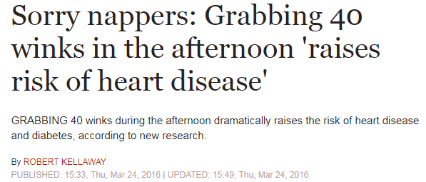

Source: <https://www.express.co.uk/life-style/health/655338/afternoon-nap-raises-risk-heart-disease>

**Task 3:**

We are interested in the causal relationship between adult socioeconomic status and subsequent dementia. Draw a causal diagram taking childhood IQ into account. Indicate what assumptions you have made.